The UK’s biggest gathering of bisexuals

their friends and allies

and those with an interest in bisexuality.

Follow us for more information and updates

Facebook and Twitter: Bicon UK

Website: 2017.bicon.org.uk

Email: Biconuk2017@gmail.com

The UK’s biggest gathering of bisexuals

their friends and allies

and those with an interest in bisexuality.

Bicon 2017

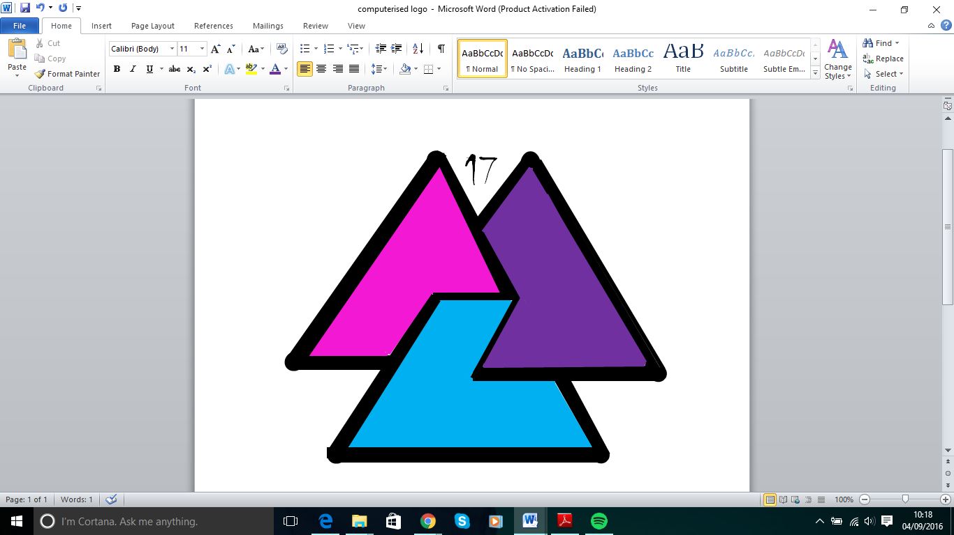

Follow us for more information and updates

Facebook and Twitter: Bicon UK

Website: 2017.bicon.org.uk

Email: Biconuk2017@gmail.com

The UK’s biggest gathering of bisexuals

their friends and allies

and those with an interest in bisexuality.

Bicon 2017



Bicon 2017

The UK’s biggest gathering of bisexuals

their friends and allies

and those with an interest in bisexuality.

Follow us for more information and updates

Facebook and Twitter: Bicon UK

Website: 2017.bicon.org.uk

Email: Biconuk2017@gmail.com

Follow us for more information and updates

Facebook and Twitter: Bicon UK

Website: 2017.bicon.org.uk

Email: Biconuk2017@gmail.com



Bicon 2017